Selective Agreement or Sycophancy? Social Influence and Opinion Dynamics in Networks of LLM Agents
Chenxi Peng, Lun Zhang*
School of Journalism and Communication, Beijing Normal University, Beijing, China
As large language models enter public information environments, generative agents are becoming interactive actors capable of continuously encountering, responding to, and recirculating others’ opinions. Classical research on opinion dynamics examines how micro-level social influence, through repeated interaction, gives rise to collective patterns such as convergence, consensus, fragmentation, and polarization (Starnini et al., 2026). Recent studies of LLM agents likewise document substantial opinion convergence. Yet convergence should not be equated automatically with sycophancy: it may instead arise from selective agreement, persuasion, or conformity (Cau et al., 2025). We therefore ask: when LLM agents participate in sustained networked discussion, what forms of social influence underlie their micro-level opinion adjustments, and how do these adjustments accumulate through repeated interaction into population-level opinion structures?
Drawing on research on social influence and group norm formation in computer-mediated communication (Postmes et al., 2000), we treat each opinion update as an event embedded in an ongoing interaction process. Rather than inferring sycophancy from convergence alone, we distinguish assimilation, conformity, selective agreement, and sycophantic alignment by jointly examining the direction of opinion change, actual information exposure, changes in reasoning, factual grounding, and confidence. Opinion shifts supported by new and credible arguments are more consistent with selective social influence, whereas movement toward a locally dominant position without such support—or despite conflicting facts or prior reasons—more closely resembles sycophantic alignment. Because each updated expression becomes part of the informational environment for subsequent agents, these micro-level responses may recursively accumulate into collective opinion patterns over time.
Methodologically, the study uses agent-based modeling (ABM) to construct a multi-round networked discussion environment populated by LLM agents. In each interaction, agents are exposed to available messages, form judgments in response to the information they encounter, decide whether to express them publicly, and thereby contribute new information to subsequent rounds. To examine the conditions under which these micro-level influence processes are amplified, constrained, or transformed into collective opinion dynamics, the main experiment adopts a 2 × 3 design manipulating social identity salience and communication network structure (Steiglechner et al., 2023). Network conditions include a no-social-interaction baseline, a degree-preserving randomized network, and a small-world network with relatively high local clustering. The system records agents’ private opinions, actual information exposures, expressed opinions, reasoning texts, and confidence judgments, enabling us to trace both event-level influence and population-level opinion trajectories.
Preliminary simulations involving 200 agents over 30 simulated rounds already reveal a strong tendency toward homogenization and directional convergence. Under weak-persona conditions, agents rapidly move toward an endpoint, while stronger, lifelong persona grounding preserves more intermediate positions and substantially slows convergence (Figure 1). These preliminary findings suggest that identity-related conditioning can shape opinion persistence and motivate a more explicit test of social identity salience in the formal design.
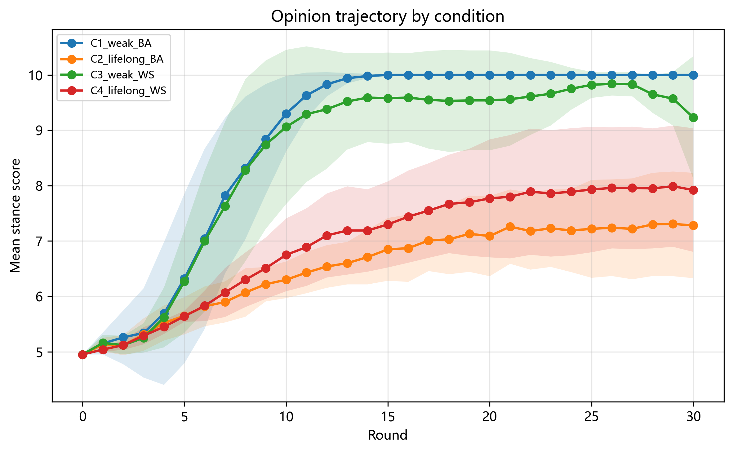
Figure 1. Preliminary opinion trajectories across persona-grounding and network-topology conditions.
Note. Earlier pilot with 200 agents over 30 simulated rounds. Weak-persona conditions (C1/C3) show rapid directional convergence toward the upper end of the opinion scale; lifelong/strong-persona conditions (C2/C4) retain more intermediate positions and converge more slowly. BA = Barabási–Albert; WS = Watts–Strogatz.
This study therefore moves the study of LLM sycophancy beyond response bias within a single user–model relationship, examining it as a potential mechanism of networked social influence and collective opinion formation. When generative agents repeatedly read, respond to, and regenerate one another’s views, apparent majorities and consensus may emerge partly from interdependent influence among agents rather than from the independent aggregation of judgments, creating artificial consensus. The societal significance lies not only in what opinions generative AI produces, but also in how such systems may reshape the perceived opinion climate of public discussion: which views appear to be held by the majority, which positions come to be treated as normal, and which disagreements appear to enjoy social support. In this way, interactions among generative agents may alter the informational environment on which people rely to judge majorities and minorities, infer social norms, and form their own opinions, with broader implications for judgment independence and opinion diversity in public discourse.

Author Biographies
Chenxi Peng is a master's student in the School of Journalism and Communication, Beijing Normal University. His research focuses on generative AI, computational communication, and AI-mediated public communication. His recent work examines generative gatekeeping and how generative AI reshapes information production and public information environments. His related work on generative gatekeeping has been published in Journalism and Mass Communication Monthly (Xinwen Jie).
Lun Zhang is a professor in the School of Journalism and Communication at Beijing Normal University. Her research focuses on computational communication, social and complex networks, opinion dynamics, social media, and the social consequences of intelligent media. Her work uses computational and network approaches to examine information diffusion, knowledge formation, news consumption, and public opinion.
References
Cau, E., Pansanella, V., Pedreschi, D., & Rossetti, G. (2025). Selective agreement, not sycophancy: Investigating opinion dynamics in LLM interactions. EPJ Data Science, 14, 59. https://doi.org/10.1140/epjds/s13688-025-00579-1
Postmes, T., Spears, R., & Lea, M. (2000). The formation of group norms in computer-mediated communication. Human Communication Research, 26(3), 341-371. https://doi.org/10.1111/j.1468-2958.2000.tb00761.x
Starnini, M., Baumann, F., Galla, T., Garcia, D., Iñiguez, G., Karsai, M., Lorenz, J., & Sznajd-Weron, K. (2026). Opinion dynamics: Statistical physics and beyond. Reviews of Modern Physics, 98(3), 035004. https://doi.org/10.1103/j1zg-ddqv
Steiglechner, P., Smaldino, P. E., Moser, D., & Merico, A. (2023). Social identity bias and communication network clustering interact to shape patterns of opinion dynamics. Journal of the Royal Society Interface, 20(209), 20230372. https://doi.org/10.1098/rsif.2023.0372

